SCHOOL NAME: Liverpool Street Elementary
Address: 50 Liverpool St
Parent School Support Committee
Minutes
Date: March 31, 2022 Time: 6:15pm
Location: Microsoft TEAMS
PSSC Members Present:  Colin Curry, Vice Chair  Keri O’Leary, Teacher Rep.  Tara Swift  Erica Fanjoy  Sabina Thapa  Asha Noel-Hart  PSSC Members Regrets:  Ronnie Stewart, Chair  Siddaiah Madadevaswamy  Bronwyn Mulherin-Murphy  Erin Wilson | School/DEC Representation Present:  Kelly Parks, Principal  Jennifer Kelly-Milner, Vice Principal  Keri O’Leary-Teacher Rep  School/DEC Representation Regrets:  Miriam MacLaughlin, DEC Rep
Call to Order: by Colin Curry 6:15pm

Approval of the Agenda:
- Approval of the Minute: Motioned by Colin Curry, seconded by Tara Swift
Business from Previous Meeting:
None to Report

Business Arising from the Minutes:

Bronwyn has shared a session that would be great for parents on mental health. She was not in attendance for today’s meeting so this will be discussed at the next meeting.

(New Business / agenda):

New Agenda items:
- 3 weeks of support to schools for supply teachers (March 14-April 1) extended to April 13. Our school was given 1 supply teacher but 0 EA’s. If we need more than our 1 supply teacher, then admin and/or resource & guidance have stepped in.
- Parent-Teacher Interviews- both virtual and in person
- Home and School- excited to begin planning for possible Spring Fling (notice going home for parent volunteers) We have about 10 people who have responded to the notice that was sent home for volunteering for the Spring Fling some time in May or June
- Possibility of a Movie Night – we are waiting to see the “health” of our kids and this current wave that is going through the school where we have so many out due to covid still. Hopefully this can happen soon if all is well.
- Year End celebrations- Grade 5 Green Hill Lake – June 6
-Grade 5 Tour at Bliss Carman – June 7 (9:30-10:30)
-Grade 1 Forest Hill Elem. Tour- June 8 at 9:00am
-Grade 2, 3, 4 – Green Hill Lake -June 13
-Grade 3 and 4 year end assembly and fun day- June 20
- Grade 2 year end assembly and fun day- June 21
-Grade 5 celebration-June 22 -9:30am
- New wood put on playground benches by District facilities. We are also looking at the tables as they are getting worn down as well. We are assessing their state and will decide after that.

- Colin asked about the absence logging by Liverpool for families. Why are we not following the district reporting through Messaging Safe Arrival? Our school is not set up for this process yet so when parents log into this, we still will call for safe arrival information. We can definitely look into setting this up; however, new services can be a bit stressful or difficult to adapt to but we can look into it for the fall.
- Tara asked about the Swim program for gr 5’s – will it be back next year after covid? We are unsure presently where covid restrictions are lifting but if things keep moving forward post covid then it will probably come back.
- Sabina – with mask restrictions lifting is it still the same for food for parties? We are now open to bring things from home as long as they are nut free.

- Principal Report:
Principal Report March 31, 2022
- Pink Shirt Day- All classes read the books -Be You! And Be Kind. Books were purchased in both French and English. Students did some activities with the books. A kind jar was in the lobby for students to write an act of kindness, compliment, or gratitude’s to someone in the school. The students enjoyed doing this. Some of the shout outs were read during the recognition assembly for February.
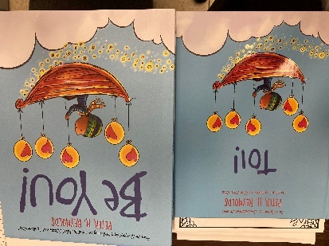
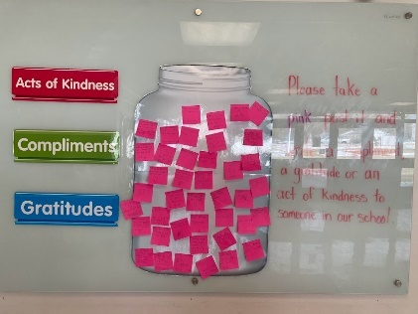

- Winter Carnival- Day 1- Snow much fun- students enjoyed painting the snow, shovel station, snow games. Crazy hair day- great photos for yearbook. Rainbow Day and Bingo to wrap up Friday afternoon.
French Culture Day- with the French Learning Grant of $1000.00, each class set up a French Café with French music playing. A placemat was created for students to learn new French vocabulary and to speak with their classmates in French. French snacks were provided- macaron, jus, crepes. Tablecloths and napkins were used to create a French Culture atmosphere. Some students drew moustaches on their faces and had Tam Hats. Students were dressed in red, blue and white to represent France. French story books were shared, and many French discussions took place about the books.
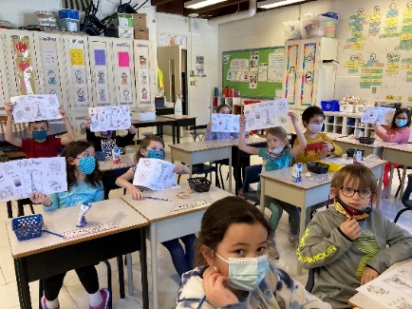
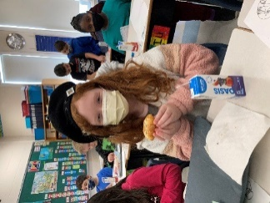

- Mactaquac Field Trip- Bird feeder activity was a hit! All students enjoyed their morning in Mactaquac.
- March 25 PL- Teachers are participated in an Art session. All staff created a masterpiece! Half of the day was spent on report cards.
- Report Cards- report cards go home on April 11, 2022. Parent-Teacher interviews will be both virtual and in person on the evening of April 13th and the morning of April 14.
- Grade 4 and Grade 5 Provincial Assessments- May 4 to 27th, grade 4 will be writing an assessment in reading and science. Grade 5 will be writing an assessment on French reading and Math. All assessments are online. Classes have started to practice how to maneuver the site, so they are familiar with all the functions and tabs. The Dept of Ed has prepared a scavenger hunt for the students and a practice run through the site.
- Yearbook-final additions are being made and photos will be submitted by early next week.
- Grade 5 2022 T-Shirts have gone out to students
- Teachers are very appreciative of the paper that PSSC gave to them.
- Have received 15 new laptops for students. They are in our “computer room”.
- All students are completing our district term 2 math assessments. Data will be shared on our “data wall” to be looked at and discussed for next steps in our School plan.
- Ms. Martell has a noon hour art club on the go right now. Students are loving it.
- Next week we have chicken eggs arriving for our life cycle unit and the Gr 2’s should have their butterfly caterpillars arriving soon.
- We had science professionals in with the Gr 5 classes this week doing some in person experiments. They loved it!
- We notice an increase in the amount of food the students are consuming from our breakfast program. It’s nice to see!

Colin asked about the data walk – what info can be shared? From first term we can tell you in literacy that the reading in the younger grades is below expected level. This is due to their last year of school and the interruptions. This data showed us that students really need that focus on guided reading especially those at the lower level. We’ve seen an improvement from students who were just below the appropriate level now up into the level they should be at. We are presently collecting data for term 2 and those figures will be known soon. Math is very much the same – we were low in the operations category (subtraction, multiplication) and this showed we needed more of a push into guided math so they do not miss out on the basics.
Any students who are really far behind the mark, they are taken out by resource teachers for small group instruction or 1 on 1 time. This is really beneficial to their learning.
Correspondence/Action Items:

Closing Comments:

Date of Next Meeting: May 12, 2022

Adjournment: 7:30pm

Motioned by Colin Curry, seconded by Tara Swift

